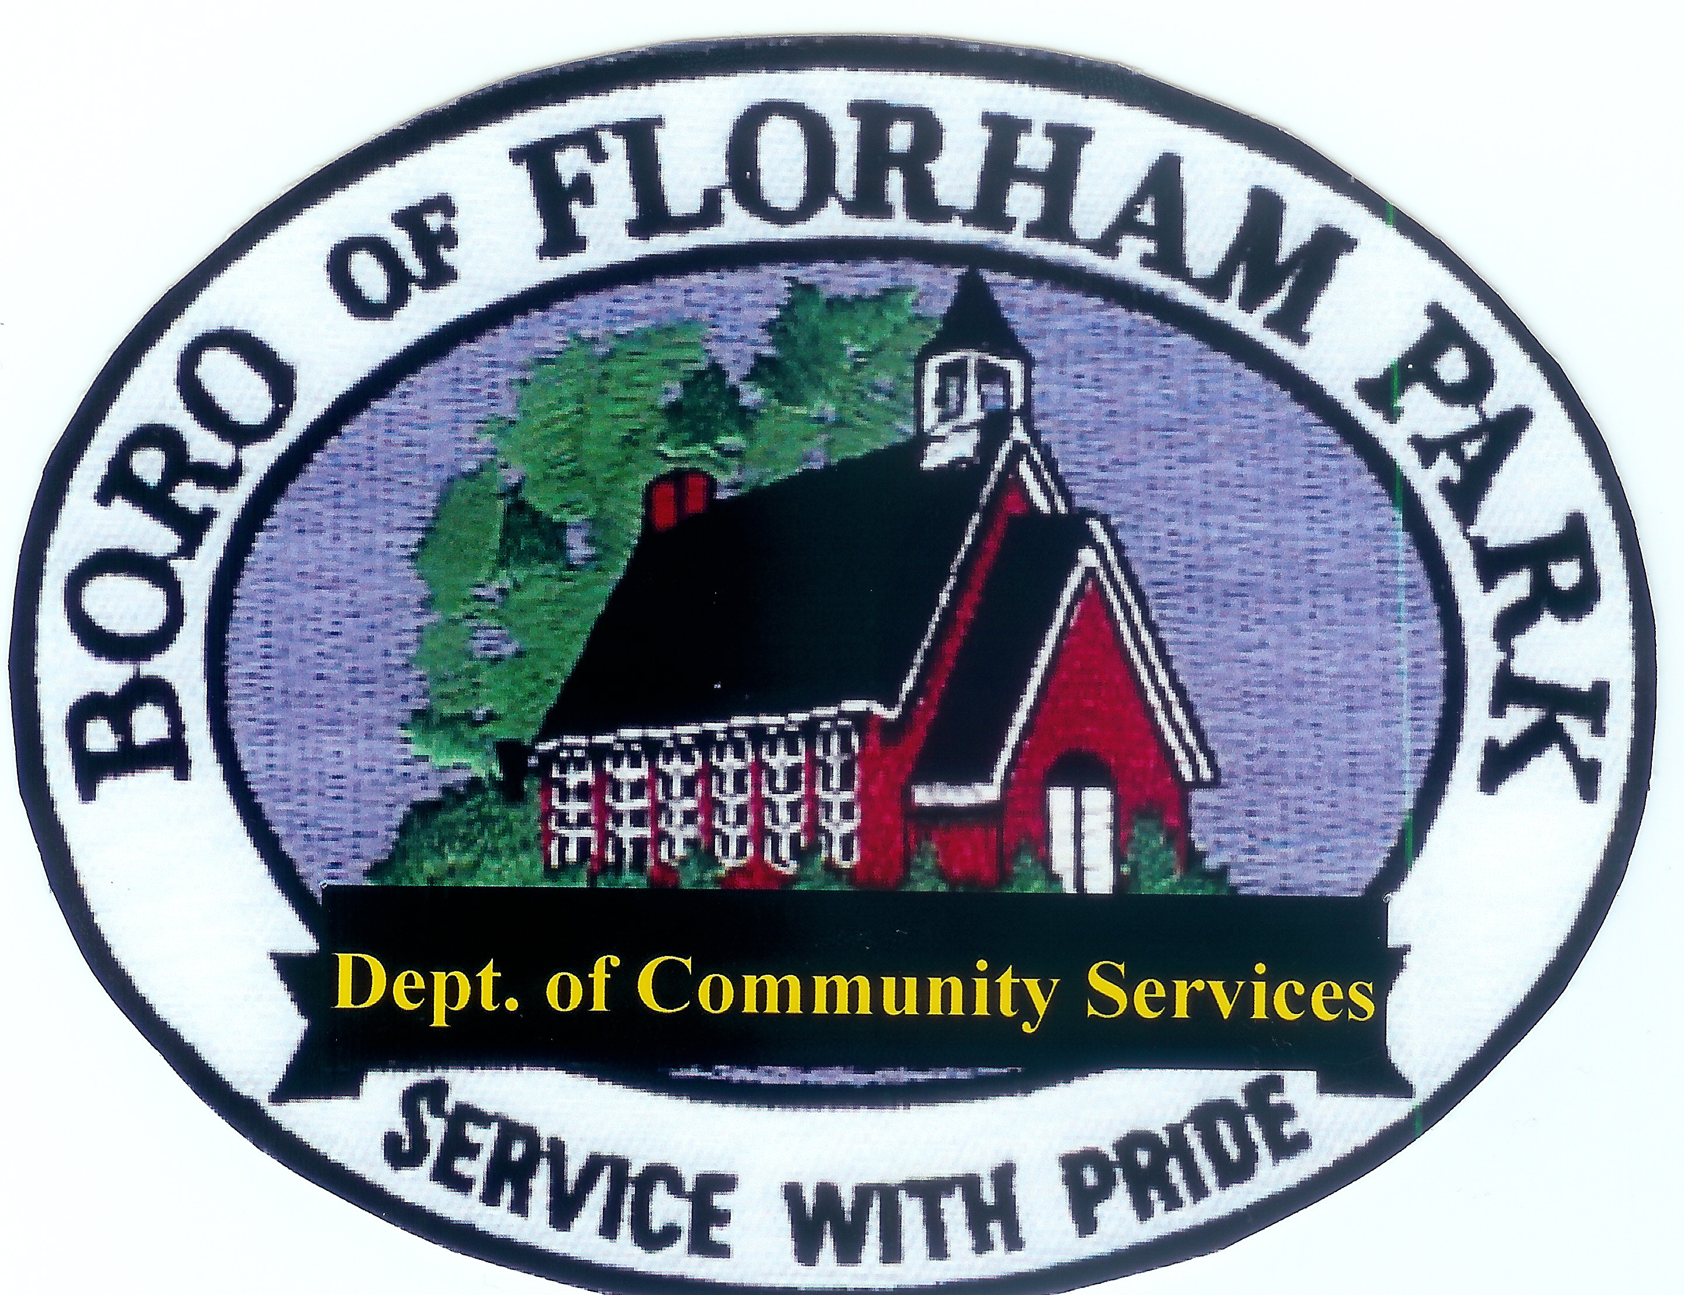
Florham Park Department of Community Services
Construction Office
111 Ridgedale Ave.
Florham Park, NJ 07932
Ph. – 973-410-5346 Fax – 973-410-5490

APPLICATION FOR TEMPORARY ZONING PERMIT
PORTABLE ON-DEMAND STORAGE CONTAINERS

No Portable Storage Container or similar storage-type temporary structure shall be placed in any area on a residential property not meeting the accessory structure setback requirements of the zone in which it lies and in no event shall a Portable Storage Container be placed in a front yard, the public right-of-way, or at any location which obstructs traffic visibility or flow as determined by the Borough Zoning Official and/or the Borough Police Chief or designee. All portable storage Containers shall be placed on a driveway, where possible. PODS must meet all requirements of the attached Ordinance #15-19 amending 250-25E 1-10.

Date:___________________________________

Property Address : ________________________________

Block ______________ Lot: ______________Zoning District______________

Dimensions of Proposed POD (length by width) _____________ Height_____________

POD will remain on site from (date) _______________ through ___________________

PLEASE SUBMIT THE FOLLOWING WITH THE COMPLETED APPLICATION
- $75.00 application fee.
- Plot Plan/survey showing the location of the proposed POD

Owner’s Name ____________________ Address:______________________________
(Please print)
Phone: ___________________________ Email: ________________________________

Signature: ________________________

For Office Use Only:

Date Received: ________________________Fee Paid _____________ Ck #____________

Approved By: _________________________Date:________________________________

Denied By :____________________________Date:_________________________________

*This permit EXPIRES on ________________ , at which time the POD MUST be removed.

